NHB+
The Right Now Process

“Millionaires don’t believe in astrology billionaires do.”

In order to make a lot of money, at some level luck ceases to be a factor.

There has to be some level of intelligence there.

https://www.grupovenus.com/infoi.asp

—

Being able to look / see reality for what it is will allow you to navigate it.

As marketers we generate desire in audiences and that is how we compel people to take action.

If you have much desire in you, then you are subservient to the external which is generating the desire within you.

Industrial grade woo-woo

Desire distorts reality

You don’t see what’s in front of you, you see what you want to see.

If you can master desire, you can take control of your life.

When we desire something we distort the value of it.

Desire plays a large part in the process of delete, distort and generalize.

A watch tells the time as any other watch, yet the desire will distort the reality of it’s actual value.

There are many processes for lowering desire and increasing will power.

One the most powerful tools you can use to make decisions is this:

Which will force your mind to look at desire as it is and how it distorts reality.

What does _____________ do for me that ____________ doesn’t?

What does _____________ give me that _____________ doesn’t?

Let's say you want to buy a new car.

What does X car do for me that my Y car doesn’t?

Desire tries to change you non stop, to go from something to something.

This question structure forces the mind to look at the defense of things as they are not as you wish them to be.

You have to have the ability to recognize differences is the key to be successful.

—

Fear tends to operate in absolutes

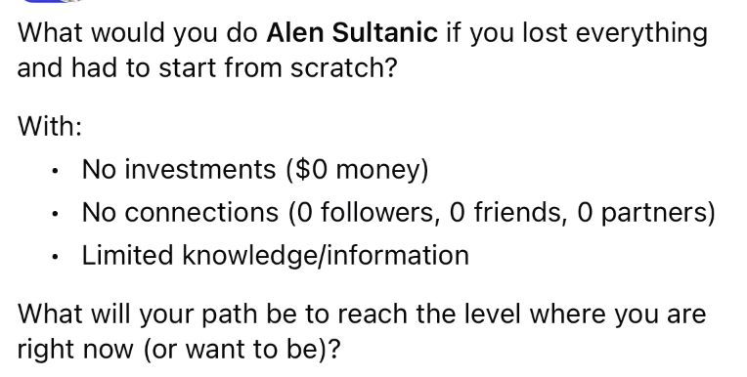
the thing is we never lose EVERYTHING

It’s impossible to lose everything

You’ll always have something

Lose money sure

Can never lose knowledge or skills

This alone will give you courage

The Secret Language of the Universe

One key to understanding
will power
and how to harness it is
This fact:
You only decide via behavior
If you SAY you'll do something
you haven't decided
if you haven't behaved in such a way

So the language of the universe is behavior, not words or thinking

I am a marketer
I am a parent
I am etc…

A true thing cannot perceive itself.

An eye can not see itself.
A hand can not touch itself
Taste buds can’t taste themselves.

There is something that can perceive the “I am”.

So the thing that is true cannot label itself.

I am a _______________

I = something
Am = possession
____ = subject

Imaginet he “I” was a jar, so it would say “Jar is a marketer”

We have an external reference which is your name, and internal reference which is the “I”

Yet something within us can recognize the I that means that we are not the I.

I am a marketer

This “I am” is a THING, it’s a THING you have but are not it.

The true thing that observes the “I” cannot perceive itself therefore we cannot label it, there is nothing to label it.
Being and having
  - Whatever you THINK you are you are slave to it
  - Whenever you think you HAVE that, you are the master
If you feel that you are that emotion then you are a slave of that emotion
The moment you say I am this, you become LIMITED by that, identified by that.

This is the 1st limiter of existence.

I am a boy
I am 10 years old
I am smart
I am tall
I am short
I am ____________
I am black
I am white

The Right Now Process

Everyone has a buying process. All humans have a buying process.

Knowing how this process works allows you to affect it, influence it and control it.

Someone always has to be in control.

Now, people hate not being in control, because they feel they have no choice.

Choice = control

I can choose, that means I’m in control.

If they are in control, then you get “let me think about it”, which basically means, let me look at my other choices to see if there is one better.

Whenever you have an audience interact with you from the moment they see the ads to the point where they buy, they are going through a buying process.

Most people are not aware that they are going through a buying process or that they have one.

They just go through with it.

Now a large part of it is based on the market criteria calls.

The criteria has to be there for them to go through the process, but there always has to be a process.

This idea of a sales process is the founding 1st principle of marketing.

And out of this we have marketers sell such things as…

…Funnel, ClickFunnels, their whole thing was a funnel based sales process.

If you look at webinar guys…that was also a sales process.

AC offer is a sales process.

Book a call is a sales process.

Google doc is a sales process.

All of these marketing concepts are just a manifestation of one or another form of a sales process.

People always have to go through a sales process.

In FF I did a call the “evaluation process”.

At the end of any sales process, what we end up with is a decision.

A decision to take action.

Anything we do to get to this decision faster and easier is of the highest value to us.

If we have a 50 step sales process and we can get them to decide in 1 step, that’s better.

If we have a 15 day sales process, if we can get them to decide in 1 day, that’s better.

Whenever you work with an offer, regardless of audience / market / etc…

There is always a process that makes it work.

Coach Tony Lee sent me a bunch of stuff, data, turns out his audience watches 3 videos.

With these 3 videos, we got them to the right now mind set.

The biggest obstacle of a sale is that they can decide later.

Right now mindset is when they can’t stop thinking about.

How many here wanted to buy something and had to talk yourself into it?

If you have to talk yourself into it, you don’t really want it.

If they have to justify it, they have to talk themselves into it and if they have to talk themselves into it, they don’t have a feeing and without a feeling they haven't bought in yet.

You’re trying to tell yourself something so you can feel something.

Right now mindset is a kinesthetic position.

It’s a state of feeling.

Once you get into the “right now” mindset, that’s when they got you. That’s when you are sold.

So how do you get them into the right now mindset. Why now not later?

Right now the mindset is that emotionally you’ve been convinced.

There’s being convinced logically, and yet there is being convinced emotionally.

The greatest brands in the world don’t try to convince you logically, they convince you emotionally .

Because you can't logically explain paying $25,000 - $50,000 for something that all it does is tells time.

That final buying pattern has been fulfilled.

So what is the final buying pattern?

They can see themselves with it, they are in mental possession of it.

They can see themselves doing something, possessing something, achieving something, etc…

If you have an offer that doesn’t match their capability, then they cannot possess it.

You have to look at capabilities, abilities and resources and match it.

If you don’t match it, you cannot experience it or get into the RIGHT NOW mindset.

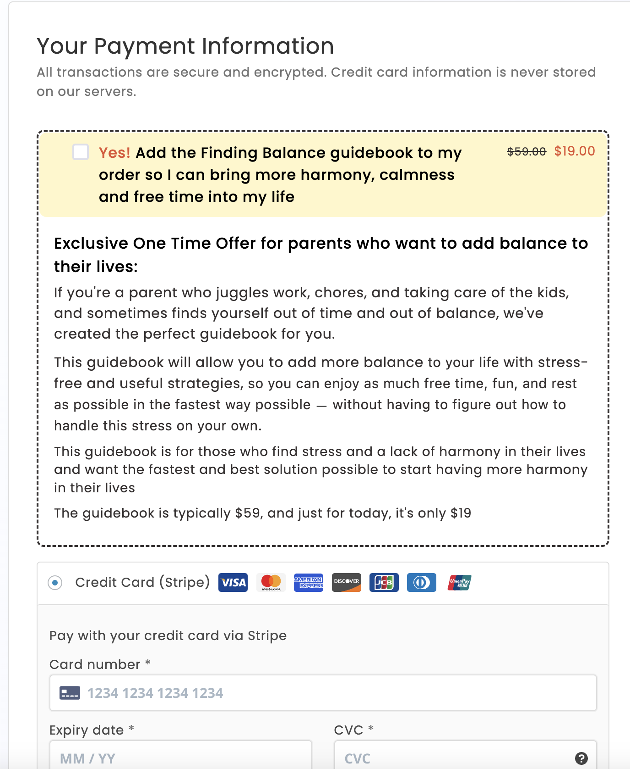

The key to everything is to get them to mentally possess it.

You have to have other things in place that let you possess something else.

You can’t sell someone furniture if they don’t have somewhere to put it.

You can’t sell women's clothes unless there is a special occasion.

You can’t sell sales material if they have nothing to sell.

You can’t sell FB ads if they have an offer, unless they want to become a media buyer.

If you look at how things are sold, most things are sold as FANTASY, not reality.

People don’t buy realities, they buy fantasies.

They have to mentally experience it or experience it.

There has to be an experience before the buying decision can be made.

3 levels of experience

- In memory
  - These are buyers, which of course makes selling them easier
- In imagination
  - This is VSLs
  - We make them imagine it
    - This is why by the way SHOW then tell works so well, they have to expend less energy
- In reality
  - You go touch stuff, test stuff, try stuff on
  - Test drive a car
  - Put the watch on
  - Whatever
  - Superstructures

Positive experience generated -> mental possession of value -> right now mind set

You can’t have emotional spending without this.

You don’t go buy something and THEN get the feeling

You get the FEELING 1st, then they give money to KEEP the feeling

If you look how luxury items are sold

Rolls-Royce, Range Rovers, BMWs, Mercedes, Patek Philppe, etc…

There is a certain WEIGHT to the materials.

It’s all kinesthetic marketing, an experience.

The kinesthetic experience justifies the emotion so the logic does not come in an interfere

Logic serves emotions

The ultimate goal of marketing is to get the logic to serve emotions.

Emotions rule logic.

If you get logic to rule emotions, it’s a done deal.

We put the LOGIC ruling the EMOTIONS on OTHER products.

So all you do is mismatch the capabilities of your audience to other products and now the logic is bak.

Emotion serves LOGIC. They are in a LATER mindset, not RIGHT NOW mindset.

The spectrum of every sales process

- Identify the audience's capabilities, resources, and such…
- Match it
- If you do not match it, they will think about it logically as to how it won’t work for them
- If there is nothing to mismatch, there is no reason to think they can’t do it
- Then they go into a state of experience, positive experience
- Then they mentally posses it
- Then once it begins to change their life, their identity and everything else
  - They can’t move forward WITHOUT it
- WITHOUT it they cannot actualize the transformation.
- It begins to possess them
- They go into the right now mindset to actualize the transformation

Who’s deciding this whole thing in the 1st place?

Past, present or future.

If they have to justify it, they have to talk themselves into it and if they have to talk themselves into it, they don’t have a feeling and without a feeling they haven't bought in yet.

All justification is the present version of themselves trying to talk to future versions of themselves into it.

All the benefit and value is in the future.
- Don’t make decisions as you are focused on the past.
- Make decisions as your future self
- Project yourself into the future, double your life. So if you are 30 years old, project to 60.
- And what would your decision be from that perspective as if you’ve already made it.
- Good decision or bad decision
All decisions are made from the future you.

That means there is an eternal conflict of change of the future you vs the present you.

So talking to the FUTURE version of them is who you are selling.

All copy should at some point begin the conversion with a future version of themselves.

And ignore the present version.

That’s the gatekeeper of the sales process.

Because every decision today is WHO they become.
So if we can affect WHO they become, it becomes that much easier to sell them.
Who you are you when you ______________

Future is where hope, dreams and transformations live.

If you think about yourself and everything you do…

…All of your payoffs are in the future.

